12.65: The change in gravitational potential energy is

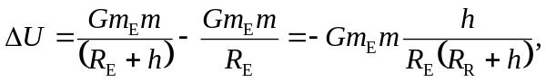
so the speed of the hammer is, from the work-energy theorem,

